Rosie Hughes

Data-Driven Journalism

February 25, 2022

**A closer look at Georgia voting bills over the past decade**

During the 2021 legislative session, Georgia voters saw their state lawmakers propose voting bills at a rate that was two and three times higher than any previous session for the past decade. The results of the 2020 election stoked a fire on both sides of the aisle to change voting procedures ahead of the next election, but the heart of the issue has been brewing since 2013.

The 2020 election delivered three major democratic wins for Georgia. Biden was the first democratic president to carry the state since Bill Clinton in 1992 and months later, in two run off elections, democrats Raphael Warnock and Jon Ossoff beat out republican contenders for Georgia’s senate seats.

Analysts like [Pew Research Center](https://www.pewresearch.org/fact-tank/2020/12/21/black-latino-and-asian-americans-have-been-key-to-georgias-registered-voter-growth-since-2016/) said the blue wave in Georgia can be attributed to the rise in Black voter turnout and other voters of color in the state since 2016.

Biden’s victory in Georgia was by no means a landslide and tight margins sent the [results to an arduous hand-count](https://www.cnn.com/2020/11/11/politics/georgia-full-state-recount-2020-presidential-race/index.html), delaying election results in Georgia for weeks. On November 19, more than two weeks after election day, Biden was officially declared the winner in Georgia’s presidential election.

According to Brenda Wright, senior advisor of legal strategies for Demos, a democracy and justice think tank, “there’s no doubt that the huge turnout in Georgia, especially among African Americans had a major impact on Georgia politics and national politics.” Wright said that because of this impact, “we saw an immediate backlash in terms of ‘how can we make voting harder?’ so that this result is more difficult to achieve in terms of mobilization of Black and Brown communities in Georgia.”

Four months later, the Republican led state legislature passed and Republican governor Brian Kemp signed the Georgia Election Integrity Act of 2021, which voting advocate Stacey Abrams has [called](https://twitter.com/staceyabrams/status/1375226721704812548?s=20&t=hgaMERpoRyhQxfisoJGvkA) “Jim Crow 2.0” and President Biden [called](https://www.cnn.com/2021/03/26/politics/joe-biden-georgia-voting-rights-bill/index.html) “Jim Crow in the 21st century.”

*To be continued….*

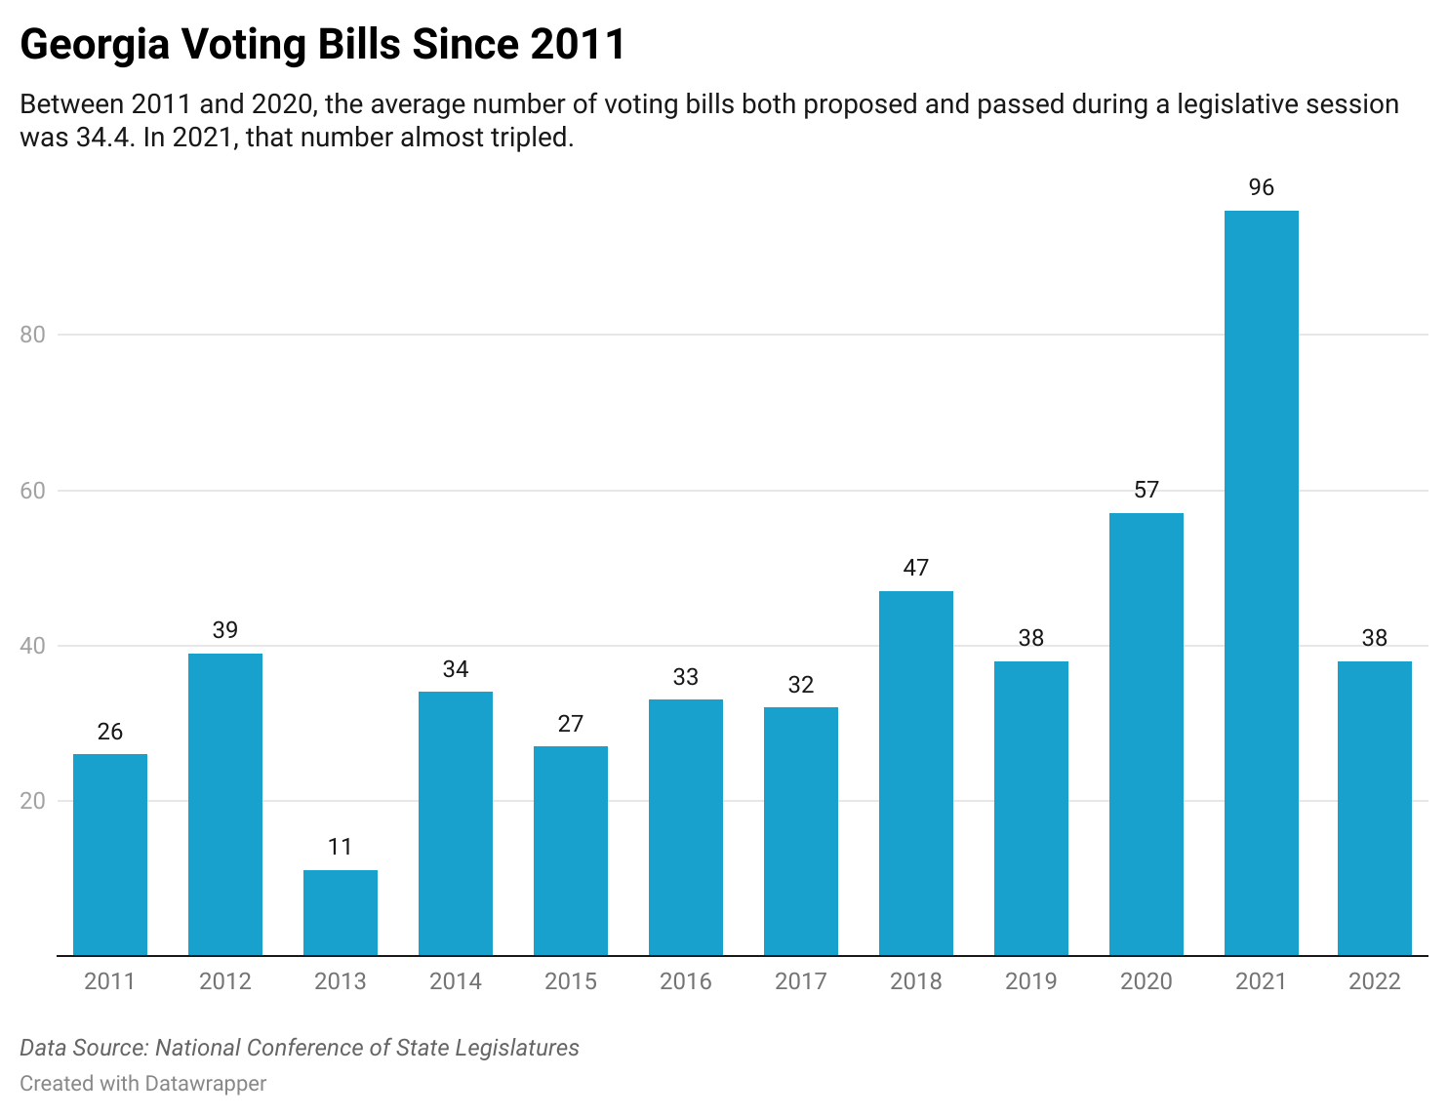

**Four questions about the data:**

1. Which political party has proposed the most voting bills over the past decade?
2. Which political party has proposed the most voting bills since the start of 2021?
3. Which issues are lawmakers targeting in their bills?
4. Which year saw the greatest number of voting bills?